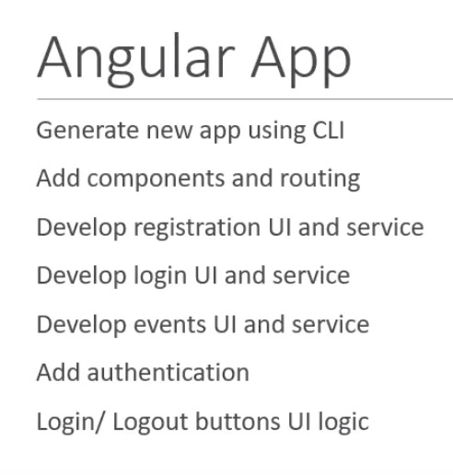

Ng new ngApp –routing

4 components

* Registration
* Login
* Regular events and special events

